**Learner Details**

* **Name:Nikhil k**
* **Enrollment Number: su625mr004**
* **Batch / Class: Mern Stack**
* **Assignment: Fruit list**
* **Date of Submission: 21-07-2025**

**Problem Solving Activity 1.1**

**1. Program Statement**

Design and implement a simple calculator using HTML, CSS, and JavaScript that allows the user to input two numbers, select an operator (+, −, ×, ÷), and display the result.

**2. Algorithm**

• Start the program.

• Accept two inputs (num1, num2) from the user.

• Accept an operator selection (+, −, ×, /).

• Check if inputs are valid numbers:

* If not, display "Please enter valid numbers."

• Based on operator:

* If +, add numbers.
* If −, subtract numbers.
* If ×, multiply numbers.
* If /, check if divisor is zero:
  + If zero → display error message.
  + Else divide normally.

• Display the result in the output area.

• End.

**3. Pseudocode**

START

INPUT num1, num2

INPUT operator

IF num1 or num2 is not a number

DISPLAY "Invalid input"

ELSE

SWITCH(operator)

CASE '+': result = num1 + num2

CASE '-': result = num1 - num2

CASE '*': result = num1 * num2

CASE '/':

IF num2 == 0

DISPLAY "Error! Cannot divide by zero"

ELSE

result = num1 / num2

END SWITCH

DISPLAY result

END IF

END

**4. Program Code**

<!DOCTYPE html>

<html lang="en">

<head>

    <meta charset="UTF-8" />

    <meta name="viewport" content="width=device-width, initial-scale=1.0" />

    <title>Calculator</title>

    <link rel="icon" href="https://img.icons8.com/color/512/apple-calculator.png" />

    <style>

        body {

            background-color: #f4f4f9;

            font-family: 'Arial', sans-serif;

        }

        .container {

            width: 100%;

            height: 100vh;

            display: flex;

            justify-content: center;

            align-items: center;

            flex-direction: column;

        }

        h1 {

            background-color: #6c4f37;

            color: white;

            padding: 15px 30px;

            border-radius: 10px;

            text-align: center;

            text-decoration: underline;

            width: 300px;

        }

        .calculator {

            background-color: #f9e3b2;

            padding: 30px;

            border-radius: 15px;

            box-shadow: 0 8px 16px rgba(0, 0, 0, 0.1);

            width: 360px;

        }

        .calculator input,

        .calculator select,

        .calculator button {

            width: 100%;

            padding: 12px;

            margin: 8px 0;

            font-size: 18px;

            border: 1px solid #ccc;

            border-radius: 8px;

            box-sizing: border-box;

        }

        .calculator button {

            background-color: #6c4f37;

            color: white;

            cursor: pointer;

            transition: background-color 0.3s ease;

        }

        .calculator button:hover {

            background-color: #8b5e3c;

        }

        #result {

            font-size: 20px;

            color: #6c4f37;

            text-align: center;

            margin-top: 20px;

        }

    </style>

</head>

<body>

    <div class="container">

        <h1>Simple Calculator</h1>

        <div class="calculator">

            <form autocomplete="off">

                <label for="num1">Number 1:</label>

                <input type="number" id="num1" placeholder="Enter number 1" />

                <label for="num2">Number 2:</label>

                <input type="number" id="num2" placeholder="Enter number 2" />

                <label for="operation">Select Operator:</label>

                <select id="operation">

                    <option value="add">+</option>

                    <option value="subtract">-</option>

                    <option value="multiply">*</option>

                    <option value="divide">/</option>

                </select>

                <button type="button" onclick="calculator()">Calculate</button>

            </form>

            <div id="result"></div>

        </div>

    </div>

    <script>

        function add(a, b) {

            return a + b;

        }

        function subtract(a, b) {

            return a - b;

        }

        function multiply(a, b) {

            return a * b;

        }

        function divide(a, b) {

            if (b === 0) return 'Error! Cannot divide by zero.';

            return a / b;

        }

        function calculator() {

            const num1 = parseFloat(document.getElementById('num1').value);

            const num2 = parseFloat(document.getElementById('num2').value);

            const operation = document.getElementById('operation').value;

            let result;

            if (isNaN(num1) || isNaN(num2)) {

                result = "Please enter valid numbers";

            } else {

                switch (operation) {

                    case 'add':

                        result = add(num1, num2);

                        break;

                    case 'subtract':

                        result = subtract(num1, num2);

                        break;

                    case 'multiply':

                        result = multiply(num1, num2);

                        break;

                    case 'divide':

                        result = divide(num1, num2);

                        break;

                    default:

                        result = 'Invalid operation';

                }

            }

            document.getElementById('result').textContent = `Result: ${result}`;

        }

    </script>

</body>

</html>

**6. Screenshots of Output**

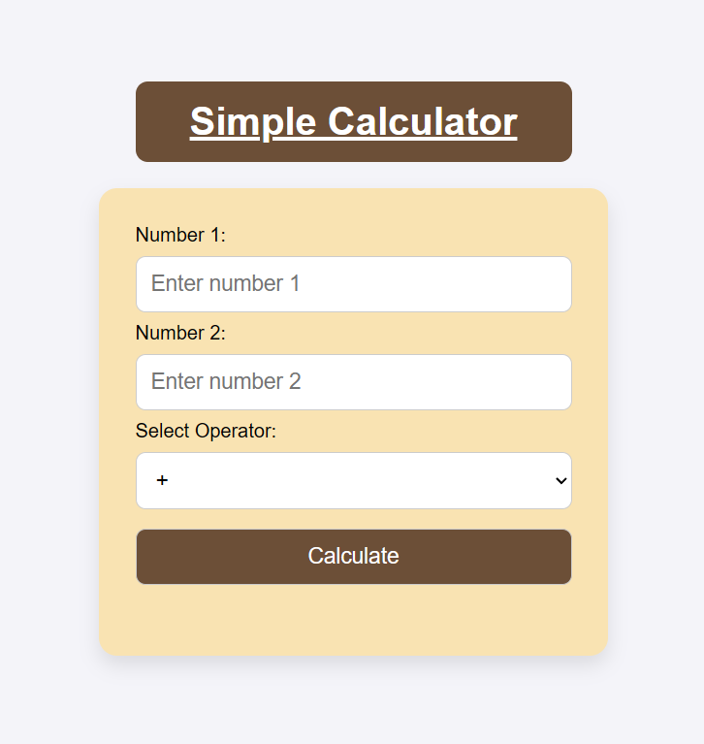

**7. Observation / Reflection**

• I learned how to structure a webpage for an online restaurant menu using HTML and interactive JavaScript functions.

• Implementing filterItems() helped me understand DOM manipulation for showing/hiding elements.

• Updating the cart count dynamically taught me how to modify webpage content in real-time.